Need help in the School Holidays?
Here are some places you can go to for support:

Warm Spaces:
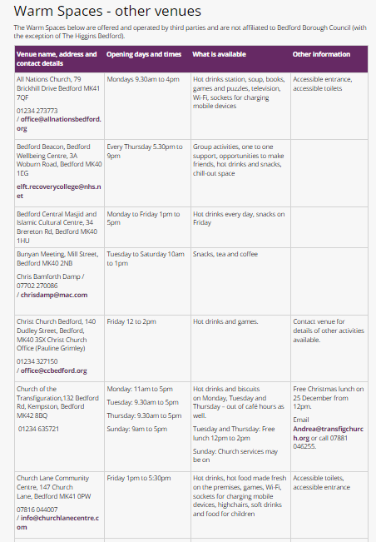

Food Bank:
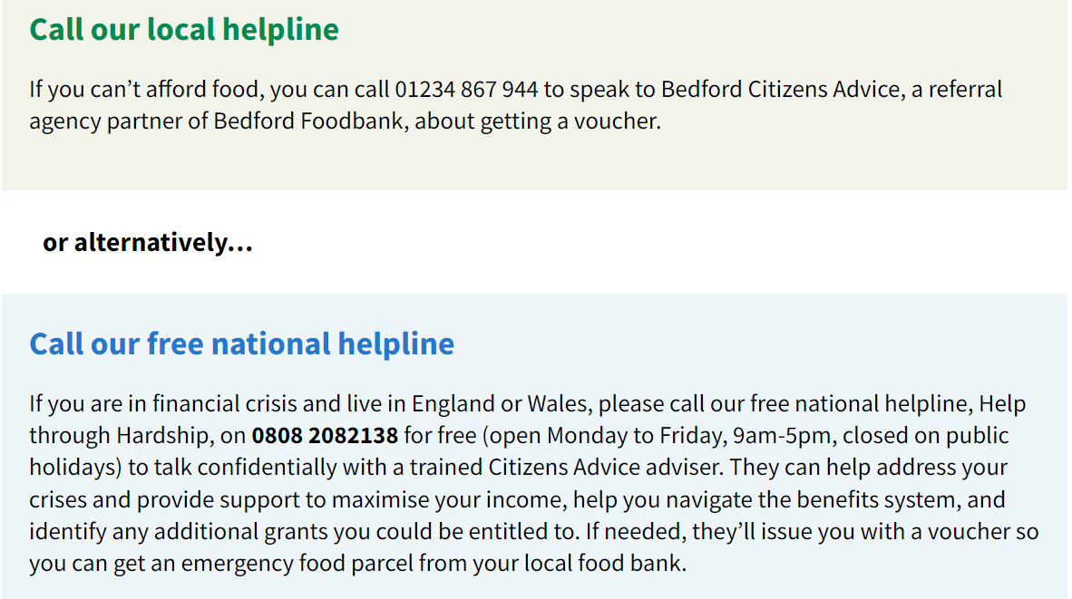

Domestic abuse:
If the incident is ongoing called the police.
Or your can call:
Refuge’s national abuse helpline on 0808 2000 247 or visit their website
www.nationaldahelpline.org.uk
For men call the men’s advice line 0808 801 0327 or email info@mensadviceline.org.uk

I’m worried about the safety of my child or another child:
Safeguarding is everyone’s responsibility – if you are worried about the safety of any child you should report it.
If you believe a child is in immediate danger then call the police - 999.
You can also call Bedfordshire Police: 01234 841212

You can report a concern to Bedford Borough Safeguarding team online
Concerned about a child? | Bedford Borough Council
Or you can call the Integrated Front Door:
- Tel: 01234 718700 (office hours)
- Tel: 0300 300 8123 (out of hours)
All cases are treated in confidence by highly experienced staff who work with children and young people.
Alternatively you can speak to the NSPCC
- NSPCC Child Protection Helpline: 0808 800 5000
I’m worried about the safety of a vulnerable adult:
You can refer online:
Bedford Borough Safeguarding Adults Team | Bedford Borough Council
Or call the team: 01234 276222

I need support with my mental health:
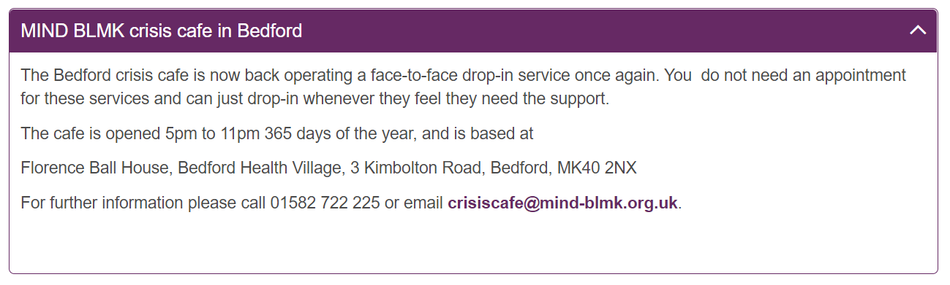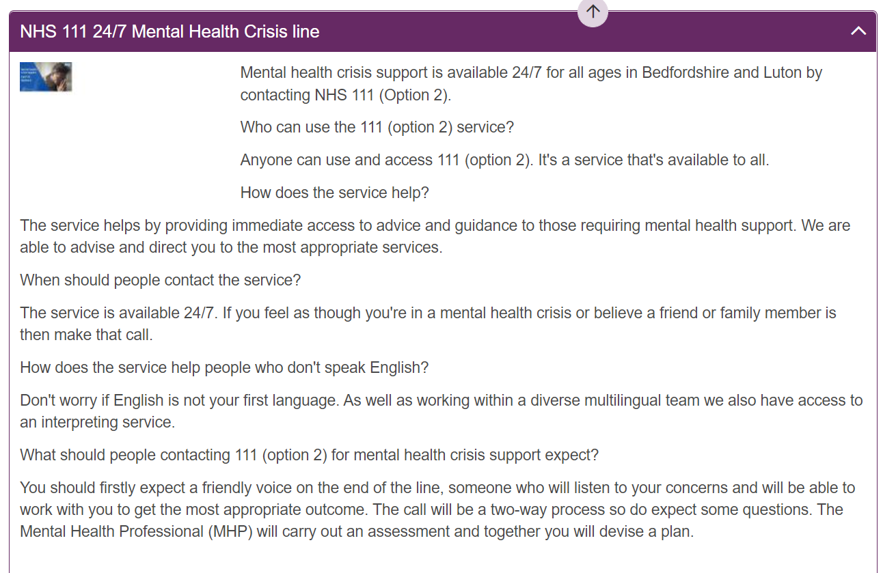
The Samaritans offer a free phone call option 24/7 on 116 123 or you can email them (24hr response time) jo@samaritans.org
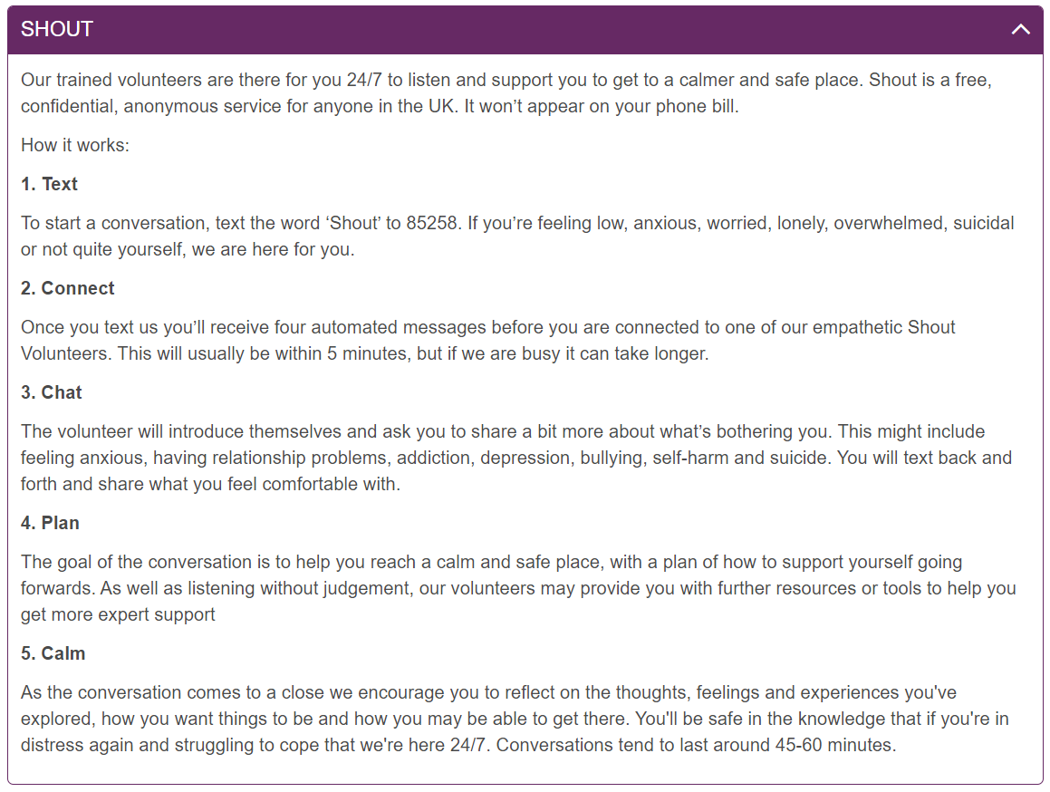
I don’t feel safe:
If you believe you are in danger please call the police – 999
Alternatively you can speak to Bedfordshire Police - 01234 841212
Don’t forget that pubs and bars operate the ‘ask for Angela’ scheme. If you are feeling unsafe in a pub or bar you can go to the bar and ‘ask for Angela’ to get on the spot support.
I or someone I know is struggling with substance abuse:
This may be something that you particularly notice during the Christmas break
Please visit Drugs and alcohol | Bedford Borough Council for a comprehensive list of tailored support available.

